|  |
| --- |
|  |
| The Documentation |
| [Type the document subtitle] |
|  |
| **[Your Name]** |
| **[Pick the date]** |

[Type the abstract of the document here. The abstract is typically a short summary of the contents of the document. Type the abstract of the document here. The abstract is typically a short summary of the contents of the document.]

Table of Contents

[To update the table of contents, right click the message below and select Update Field (F9 on PC, ⌥⌘U on Mac).]

**No table of contents entries found.**

1. Pages
   1. Page Tree

App with Device Frame  
 TaskFlow

* 1. App with Device Frame
     1. User Interface

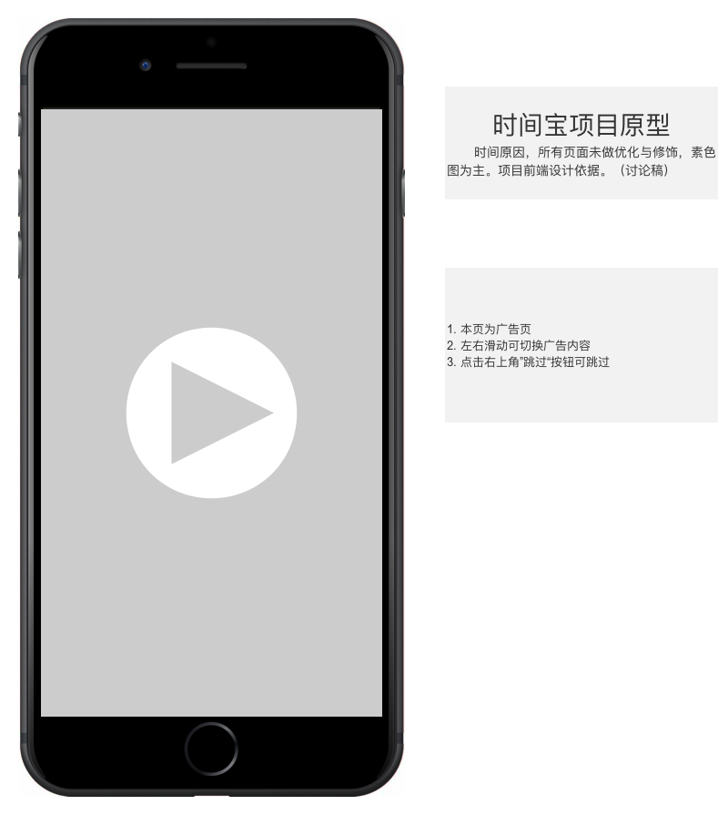

* 1. TaskFlow
     1. User Interface

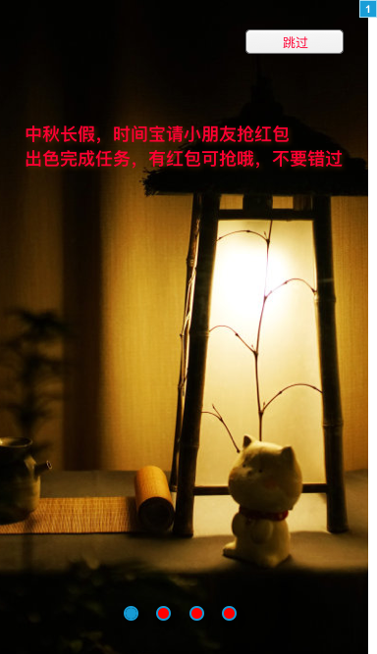

* + 1. Widget Table

| Footnote | Name | Interactions |
| --- | --- | --- |
| 1 | 前置广告 | OnSwipeLeft:  Case 1:  Set 前置广告 to Next slide left out 500ms slide left in 500ms wrap OnSwipeRight:  Case 1:  Set 前置广告 to Previous slide right out 500ms slide right in 500ms wrap OnLoad:  Case 1:  Set 前置广告 to Next slide left out 500ms slide left in 500ms wrap repeat every 5000 ms delay first change |
| 2 | home | OnLoad:  Case 1:  Hide Settings |
| 3 | Task | OnSwipeLeft:  Case 1:  Set 纪录 to Next slide left out 500ms slide left in 500ms OnSwipeRight:  Case 1:  Set 纪录 to Previous slide right out 500ms slide right in 500ms OnLoad:  Case 1:  Set text on day equal to "[[Now.getDay()]]日", and  text on month equal to "[[Now.getMonth()]]月"  Set text on SUM1 equal to "0"  Rotate clock pointer2 to -90 deg clockwise anchor bottom left, clock pointer1 to -90 deg clockwise anchor bottom left  Hide recorder, 纪录 |

* + 1. home
       1. State1
       2. User Interface

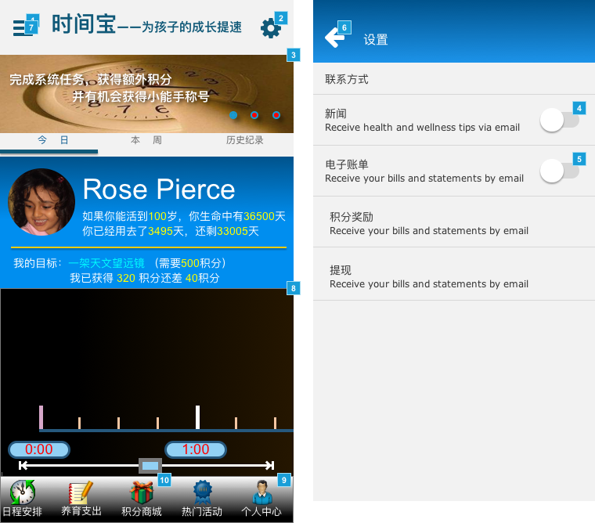

* + - 1. Widget Table

| Footnote | Name | Interactions |
| --- | --- | --- |
| 1 | bars sliding menu button | OnClick:  Case 1:  Bring sliding menu to Front   Show sliding menu slide right 500 ms |
| 2 | gear settings menu button | OnClick:  Case 1:  Show Settings  Move Settings to (15,0) |
| 3 | swiping slideshow | OnSwipeLeft:  Case 1:  Set This to Next slide left out 500ms slide left in 500ms wrap  Wait 600 ms  Set value of OnLoadVariable equal to state of This  Set text on Unidentified equal to "[[OnLoadVariable]] of 3" OnSwipeRight:  Case 1:  Set This to Previous slide right out 500ms slide right in 500ms wrap  Wait 600 ms  Set value of OnLoadVariable equal to state of This  Set text on Unidentified equal to "[[OnLoadVariable]] of 3" |
| 4 | toggle switch 1 | OnClick:  Case 1:  Set This to Next wrap |
| 5 | toggle switch 2 | OnClick:  Case 1  (If is selected of This does not equal true):  Set is selected of This equal to "true"  Move handle by (20,0) swing 250ms  Case 2  (Else If True):  Set is selected of This equal to "false"  Move handle by (-20,0) swing 250ms |
| 6 | arrow home screen button | OnClick:  Case 1:  Hide Settings fade 300 ms  Move Settings to (0,20) swing 350ms |
| 7 | arrow home screen button | OnClick:  Case 1:  Hide sliding menu slide left 400 ms |
| 8 | scrollbar hider | OnLoad:  Case 1:  Set swiping slideshow to Next wrap repeat every 3000 ms delay first change |
| 9 |  | OnClick:  Case 1:  Set Task to Personal  Show Task |
| 10 |  | OnClick:  Case 1:  Set Task to E-commerce  Show Task bring to front |

* + 1. scrollbar hider
       1. State1
       2. User Interface

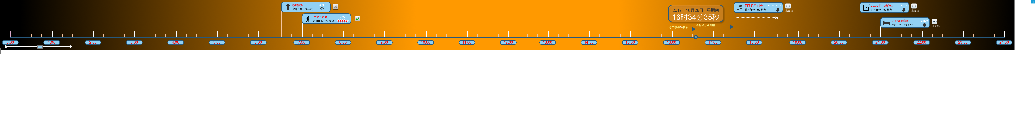

* + - 1. Widget Table

| Footnote | Name | Interactions |
| --- | --- | --- |
| 1 | content | OnDrag:  Case 1:  Move content with drag x  Move POINTER to ([[This.x/4790*-355]],217) OnDragDrop:  Case 1  (If area of This is not over area of left):  Move content to (0,0) linear 500ms  Case 2  (Else If area of This is not over area of right):  Move content to (-4535,0) linear 500ms OnLoad:  Case 1:  Move content to (-3200,0)  Move POINTER to (213,217) |

* + 1. content
       1. State1
       2. User Interface



* + - 1. Widget Table

| Footnote | Name | Interactions |
| --- | --- | --- |
| 1 | time | OnPanelStateChange:  Case 1:  Set text on time2 equal to "16时34分[[Now.getSeconds()]]秒", and  text on time1 equal to "16时34分[[Now.getSeconds()]]秒" OnLoad:  Case 1:  Set time to Next wrap repeat every 1000 ms delay first change  Set text on time2 equal to "16时34分[[Now.getSeconds()]]秒", and  text on time1 equal to "16时34分[[Now.getSeconds()]]秒" |
| 2 |  | OnClick:  Case 1:  Show Task fade 500 ms, Hide home  Set Task to executive show if hidden |

* + 1. time
       1. State1
       2. User Interface

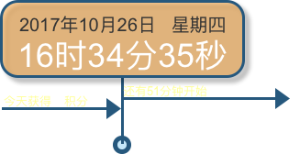

* + - 1. State2
      2. User Interface

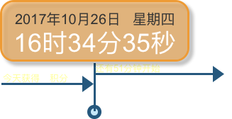

* + 1. swiping slideshow
       1. 1
       2. User Interface

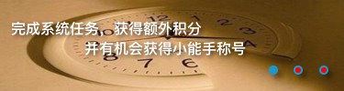

* + - 1. 2
      2. User Interface



* + - 1. 3
      2. User Interface



* + 1. chid
       1. State1
       2. User Interface



* + - 1. Widget Table

| Footnote | Name | Interactions |
| --- | --- | --- |
| 1 | BabyProfil | OnClick:  Case 1:  Set BabyProfil to Next fade out 500ms fade in 500ms wrap |

* + 1. BabyProfil
       1. State1
       2. User Interface



* + - 1. State2
      2. User Interface



* + - 1. State3
      2. User Interface



* + 1. toggle switch 1
       1. off
       2. User Interface



* + - 1. on
      2. User Interface



* + 1. 登录
       1. State1
       2. User Interface



* + - 1. Widget Table

| Footnote | Name | Interactions |
| --- | --- | --- |
| 1 |  | OnClick:  Case 1:  Show 发送验证, 验证, 验证 |
| 2 |  | OnClick:  Case 1:  Show home slide up 500 ms, Hide 登录  Set home to State1 |

* + 1. Task
       1. executive
       2. User Interface



* + - 1. Widget Table

| Footnote | Name | Interactions |
| --- | --- | --- |
| 1 | arrow home screen button | OnClick:  Case 1:  Hide Task  Show home |
| 2 | Dclock | OnPanelStateChange:  Case 1  (If text on SUM2 is less than or equals "60"):  Set text on SUM1 equal to "[[LVAR1+1]]"  Set text on SUM2 equal to "[[LVAR1+1]]"  Rotate clock pointer1 to [[LVAR1*6-90]] deg clockwise anchor bottom left, clock pointer2 to [[LVAR1*6-90]] deg clockwise anchor bottom left  Case 2  (Else If text on SUM2 is greater than "60"):  Set text on over equal to "停止计时" |
| 3 | start | OnClick:  Case 1:  Set Dclock to Next wrap repeat every 1000 ms delay first change  Set Panel to State  Hide This  Set text on over equal to "暂停计时"  Show over |
| 4 | over | OnClick:  Case 1  (If text on SUM2 is less than "60"):  Set Dclock to State1 show if hidden  Set text on start equal to "继续计时"  Show start, Hide This  Case 2  (Else If True):  Enable This  Set Dclock to State1 show if hidden  Disable This |
| 5 | time | OnPanelStateChange:  Case 1:  Set text on time1 equal to "16时34分[[Now.getSeconds()]]秒", and  text on time1 equal to "16时34分[[Now.getSeconds()]]秒" OnLoad:  Case 1:  Set time to Next wrap repeat every 1000 ms delay first change  Set text on time1 equal to "16时34分[[Now.getSeconds()]]秒", and  text on time1 equal to "16时34分[[Now.getSeconds()]]秒" |
| 6 |  | OnClick:  Case 1:  Set recorder to State1 show if hidden  Move recorder to (0,0) |
| 7 |  | OnClick:  Case 1:  Show others bring to front  Move others to (0,0) |
| 8 | share | OnClick:  Case 1:  Hide This slide left 500 ms |
| 9 |  | OnClick:  Case 1:  Show share slide right 500 ms |

* + - 1. Personal
      2. User Interface



* + - 1. Widget Table

| Footnote | Name | Interactions |
| --- | --- | --- |
| 1 | arrow home screen button | OnClick:  Case 1:  Hide Task  Show home |
| 2 |  | OnClick:  Case 1:  Show/Hide Widget  Move Widget |
| 3 | baby | OnItemLoad:  Case 1:  Set text on (Rectangle) equal to "[[Item.name]]网名：[[Item.username]]性别：[[Item.Sex]]生日：[[Item.Bday]]积分：[[Item.Sum]]"  Set babyImg image to [[Item.Img]] |
| 4 | Switch | OnClick:  Switch:  Set This to Next wrap |
| 5 | Switch | OnClick:  Switch:  Set This to Next wrap |

* + - 1. E-commerce
      2. User Interface

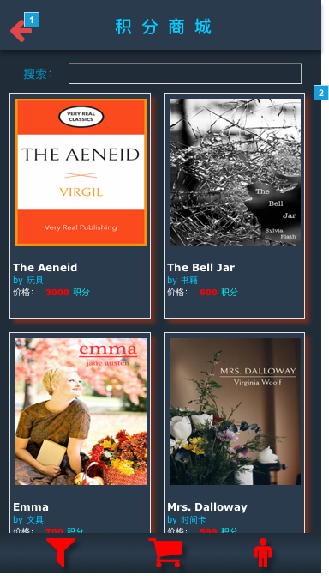

* + - 1. Widget Table

| Footnote | Name | Interactions |
| --- | --- | --- |
| 1 | arrow home screen button | OnClick:  Case 1:  Hide Task  Show home |
| 2 |  | OnDrag:  Case 1:  Move (Group) with drag y |

* + 1. Dclock
       1. State1
       2. User Interface

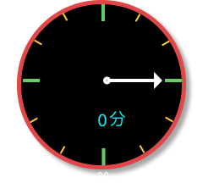

* + - 1. State2
      2. User Interface



* + 1. time
       1. State1
       2. User Interface



* + - 1. State2
      2. User Interface



* + 1. 纪录
       1. State1
       2. User Interface

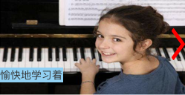

* + - 1. State2
      2. User Interface

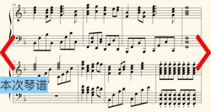

* + - 1. State3
      2. User Interface



* + 1. recorder
       1. State1
       2. User Interface



* + - 1. Widget Table

| Footnote | Name | Interactions |
| --- | --- | --- |
| 1 |  | OnClick:  Case 1:  Set recorder to State2 |

* + - 1. State2
      2. User Interface



* + - 1. Widget Table

| Footnote | Name | Interactions |
| --- | --- | --- |
| 1 |  | OnClick:  Case 1:  Hide recorder  Show 纪录 |

* + 1. others
       1. State1
       2. User Interface



* + - 1. Widget Table

| Footnote | Name | Interactions |
| --- | --- | --- |
| 1 | Books | OnItemLoad:  Case 1:  Set Cover image to [[Item.Cover]]  Set text on Info equal to "[[Item.Title]][[Item.Author]] ❤️ [[Item.ProductPage]]" |
| 2 |  | OnSwipeLeft:  Case 1  (If "[[LVAR1.pageIndex]]" equals "1"):  Set Current Page of Books to Next  Show right, Hide left OnSwipeRight:  Case 1  (If "[[LVAR1.pageIndex]]" equals "2"):  Set Current Page of Books to Previous  Show left, Hide right OnLoad:  Case 1:  Set text on (Rectangle) equal to "第 [[LVAR1.pageIndex]] 页" |
| 3 | arrow home screen button | OnClick:  Case 1:  Show Task  Set Task to executive  Hide others |

* + 1. Unnamed
       1. State1
       2. User Interface



* + 1. Switch
       1. On
       2. User Interface



* + - 1. Off
      2. User Interface



* + 1. Switch
       1. On
       2. User Interface



* + - 1. Off
      2. User Interface



* + 1. Unnamed
       1. State1
       2. User Interface

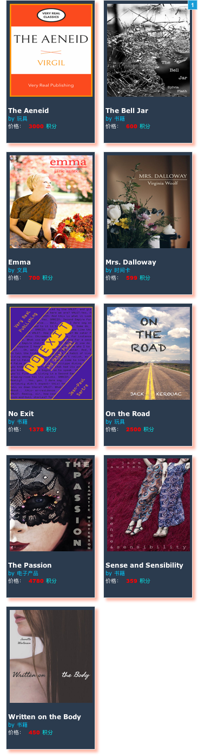

* + - 1. Widget Table

| Footnote | Name | Interactions |
| --- | --- | --- |
| 1 | Books | OnItemLoad:  Case 1:  Set Cover image to [[Item.Cover]]  Set text on Info equal to "[[Item.Title]]by [[Item.Author]]价格： [[Item.Price]] 积分" |

* + 1. 前置广告
       1. State1
       2. User Interface



* + - 1. Widget Table

| Footnote | Name | Interactions |
| --- | --- | --- |
| 1 |  | OnClick:  Case 1:  Hide 前置广告  Set 登录 to State1  Show 登录 |

* + - 1. State2
      2. User Interface



* + - 1. Widget Table

| Footnote | Name | Interactions |
| --- | --- | --- |
| 1 |  | OnClick:  Case 1:  Hide 前置广告 fade 500 ms  Show 登录  Set 登录 to State1 |

* + - 1. State3
      2. User Interface



* + - 1. Widget Table

| Footnote | Name | Interactions |
| --- | --- | --- |
| 1 |  | OnClick:  Case 1:  Hide 前置广告  Show 登录  Set 登录 to State1 |

* + - 1. State4
      2. User Interface



* + - 1. Widget Table

| Footnote | Name | Interactions |
| --- | --- | --- |
| 1 |  | OnClick:  Case 1:  Hide 前置广告  Set 登录 to State1 fade out 500ms fade in 500ms show if hidden |

* + 1. Books
       1. User Interface



* + - 1. Widget Table

| Footnote | Name | Interactions |
| --- | --- | --- |
| 1 |  | OnClick:  Case 1:  Open [[Item.ProductPage]] in New Window/Tab |

* + 1. baby
       1. User Interface



* + 1. Books
       1. User Interface

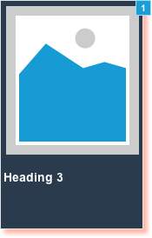

* + - 1. Widget Table

| Footnote | Name | Interactions |
| --- | --- | --- |
| 1 |  | OnClick:  Case 1:  Open [[Item.ProductPage]] in New Window/Tab |

1. Masters
   1. Master List

Chevron  
Select Option Checkmark  
iPhone 5 - Navigation Bar BG Color  
Back Chevron  
Status Bar - iPhone 5  
Back Chevron - iPhone 6  
Status Bar - iPhone 6

* 1. Chevron
     1. User Interface



* 1. Select Option Checkmark
     1. User Interface



* 1. iPhone 5 - Navigation Bar BG Color
     1. User Interface



* 1. Back Chevron
     1. User Interface



* + 1. Back Chevron
       1. Back Chevron
       2. User Interface



* 1. Status Bar - iPhone 5
     1. User Interface



* + 1. Status Bar
       1. Black Status
       2. User Interface



* + - 1. White Status
      2. User Interface



* 1. Back Chevron - iPhone 6
     1. User Interface



* + 1. Back Chevron
       1. Back Chevron
       2. User Interface



* 1. Status Bar - iPhone 6
     1. User Interface



* + 1. Status Bar
       1. Black Status
       2. User Interface



* + - 1. White Status
      2. User Interface

